

**DEPARTMENT OF ARTIFICIAL INTELLIGENCE AND DATA SCIENCE**

**INTERNAL HACKATHON - 2022**

**Internal Institute Level Hackathon Details - SIH2022**

**Department Faculty / Jury Members Details:**

|  |  |  |  |  |
| --- | --- | --- | --- | --- |
| **Name of the Faculty /Jury** | **Designation of Faculty /Jury** | **Organization of Jury** | **Mobile No of Faculty /Jury** | **Email ID of Faculty /Jury** |
| NEVINKUMAR.A | SYSTEM ENGINEERING | TCS, CHENNAI | 9629360207 | [nevinrocky6@gmail.com](mailto:nevinrocky6@gmail.com) |
| JEEVANANTHAM | DEVELOPER | ZOHO, CHENNAI | 7373638389 | [d.jeeva6@gmail.com](mailto:d.jeeva6@gmail.com) |
| JAWAHAR | SYSTEM ENGINEERING | TCS,CHENNAI | 8754747001 | [Jawahara1997@gmail.com](mailto:Jawahara1997@gmail.com) |
| DHAMODHARAN | SAP CONSULTANT | KAAR,SAUDI ARABIA | 9952478932 | [dhamo.exortian@gmail.com](mailto:dhamo.exortian@gmail.com) |

**Department Student Team Registration Details**

* **Total no. of Teams Participated - 9**
* **Total no. of Student Participated - 54**
* **No. Of female Participants - 17**
* **No. Of male Participants - 37**

**HOD/ AI&DS**



**DEPARTMENT OF ARTIFICIAL INTELLIGENCE AND DATA SCIENCE**

**INTERNAL HACKATHON - 2022**

|  |  |  |  |  |  |  |  |
| --- | --- | --- | --- | --- | --- | --- | --- |
| **S.No** | **Team Name** | **Problem Statement Id** | **Category (Software/**  **Hardware/Both)** | **Problem Statement Name** | **Email ID and Mobile No of Student** | **Mentor Name & Designation** | **Jury Score**  **(100)** |
| **1** | **TECH OWLS** | **DR710** | **SOFTWARE** | **CAREER DENDROGRAM** | **1.RAHUL GANDHI.A.M**  [**Rahulgandhiaids@smvec.ac.in**](mailto:Rahulgandhiaids@smvec.ac.in)  **8056437721**  **2..SANTHANA BHARATHI**  [**santhanabharathiaids@smvec.ac.in**](mailto:santhanabharathiaids@smvec.ac.in)  **6369503768**  **3.BHAVIN DHANARJ.V**  [**bhavinaids@smvec.ac.in**](mailto:bhavinaids@smvec.ac.in)  **8056312272**  **4.SARANYA.M**  [**saranyaaids@smvec.ac.in**](mailto:saranyaaids@smvec.ac.in)  **9894834628**  **5.HARINI.S**  [**hariniaids@smvec.ac.in**](mailto:hariniaids@smvec.ac.in)  **9940317305**  **6.ANNI SHARLEENA.A.B**  [**annisharleenaaids@smvec.ac.in**](mailto:annisharleenaaids@smvec.ac.in)  **8807502654** |  |  |
| **2** | **TITANS** | **DB880** | **SOFTWARE** | **ENAID** | **1.GOKUL PRASATH**  [g**okulprasanth100702@.com**](mailto:gokulprasanth100702@.com)  **9943170426**  **2. RAGUL . .S**  [**Slrk4444@gmail.com**](mailto:Slrk4444@gmail.com)  **3.HARIGUPTHA.A**  [**harihariguptha@gmail.com**](mailto:harihariguptha@gmail.com)  **9080584360**  **4.MOHITA.V**  [m**ohivelu01@gmail.com**](mailto:mohivelu01@gmail.com)  **9791080985**  **5.GHAYATRI.H**  [**Ghayu1529@gmail.com**](mailto:Ghayu1529@gmail.com)  **8438665029**  **6.AISWARYA.A.V**  [**alvaiswary@gmail.com**](mailto:alvaiswary@gmail.com)  **7094309929** |  |  |
| **3** | **THE TECH MANIACS** | **PK848** | **SOFTWARE** | **AUTOMATED NOTES MAKER FROM AUDIO RECODINGS** | **1.DHARNIKA .B**  [d**harnika09@gmail.com**](mailto:dharnika09@gmail.com)  **8610106228**  **2. RAAGA VARSHINI .B**  [v**arshiniraaga28@gmail.com**](mailto:varshiniraaga28@gmail.com)  **8946042531**  **3. ABINAV.S**  [**Abinavabinav100@gmail.com**](mailto:Abinavabinav100@gmail.com)  **8760991234**  **4.AABITH.M.A**  [**Aabith1705@gmail.com**](mailto:Aabith1705@gmail.com)**.**  **6381507551**  **5.KALAIARASAN.K**  [**Mrmaddy046@gmail.com**](mailto:Mrmaddy046@gmail.com)  **6385590462**  **6.GOKULNATH.T**  [**gokulnaththiyagarajan@gmail.com**](mailto:gokulnaththiyagarajan@gmail.com)  **9345482712** |  |  |
| **4** | **LUCID THINKERS** | **NR1099** | **SOFTWARE** | **TO AUTOMATE AND COMPUTE THE DETECTION OF POSSIBLE VLULNERABILITY TO DEPRESSION BEFORE ITS ONSET** | **1.VASAN.C**  [**vasanaids@smvec.ac.in**](mailto:vasanaids@smvec.ac.in)  **6385339037**  **2.BALAJI.S**  [**balajiaids@smvec.ac.in**](mailto:balajiaids@smvec.ac.in)  **6382472292**  **3. ADITHYAN.A**  [a**dithyanaids@smvec.ac.in**](mailto:adithyanaids@smvec.ac.in)  **7708266927**  **4. HARISH.E**  [**harishaids@smvec.ac.in**](mailto:harishaids@smvec.ac.in)  **8300949331**  **5.GAYATHRI.S**  [**gayathriaids@smvec.ac.in**](mailto:gayathriaids@smvec.ac.in)  **8526329498**  **6. PARKKAVAN.I**  [**parkkavanaids@smvec.ac.in**](mailto:parkkavanaids@smvec.ac.in)  **7598606206** |  |  |
| **5** | **CODE FELLAS** | **NC740** | **SOFTWARE** | **MOVING VEHICLE REGISTRATION DETECTION** | **1.KIRUBHA SHANKAR.S**  [**kirubhashankarsudharshan@gmail.com**](mailto:kirubhashankarsudharshan@gmail.com)  **9025674310**  **2.AMITA.C**  [**amita1527@gmail.com**](mailto:amita1527@gmail.com)  **9150748779**  **3.MUGILAN.V**  [**Mugivetri1573@gmail.com**](mailto:Mugivetri1573@gmail.com)  **6382656924**  **4.SWATHY**  [**Swathyankita22@gmail.com**](mailto:Swathyankita22@gmail.com)  **9384563339**  **5.SRI HARISH.**  [**Sriharish2002@gmail.com**](mailto:Sriharish2002@gmail.com)  **6382949401**  **6.KEERTHI RAJ**  [**keerthirockd@gmail.com**](mailto:keerthirockd@gmail.com)  **9080808459** |  |  |
| **6** | **DATA WITH DESTINY** | **SM946** | **SOFTWARE** | **PREDICTION OF PNEUMONIA** | **1.GANAPATHY**  [**ganapathyaids@smvec.ac.in**](mailto:ganapathyaids@smvec.ac.in)  **9080056455**  **2.LALITH KANTH**  [**lalithkanthaids@smvec.ac.in**](mailto:lalithkanthaids@smvec.ac.in)  **9566729529**  **3.ARAVINDH**  [**aravindhaids@smvec.ac.in**](mailto:aravindhaids@smvec.ac.in)  **6382106607**  **4.BOOMIKA**  [**boomikaannamalai2520@gmail.com**](mailto:boomikaannamalai2520@gmail.com)  **9345553085**  **5. VALAR OLI**  [**olivalar287@gmail.com**](mailto:olivalar287@gmail.com)  **9514448585**  **6. VARSHINI**  [**varshiniaids@smvec.ac.in**](mailto:varshiniaids@smvec.ac.in)  **6385473354** |  |  |
| **7** | **TECHNO SAPIENS** | **ST890** | **SOFTWARE** | **INSUFFICIENT MEDICAL SUPPORT AND REMOTE VILLAGE IN HILL AREAS** | **1.ROHIT.S.K**  [r**ohitsk2003@gmail.com**](mailto:rohitsk2003@gmail.com)  **9884511376**  **2.FERON AROCKIAM.S**  [f**eronarockiam1493@gmail.com**](mailto:feronarockiam1493@gmail.com)  **9944427493**  **3.HARII SARAVANAN.A**  [h**ariisaravanan99@gmail.com**](mailto:hariisaravanan99@gmail.com)  **9791240115**  **4. ANDREW JASON.R**  [**andrewjasonr@gmail.com**](mailto:andrewjasonr@gmail.com)  **8903670387**  **5.NARESH.S**  [n**areshsuresh589@gmail.com**](mailto:nareshsuresh589@gmail.com)  **9626390122**  **6.ABITHA.S**  [a**bithas2711@gmail.com**](mailto:abithas2711@gmail.com)  **6380507365** |  |  |
| **8** | **CODE X SYNDROME** | **PK847** | **SOFTWARE** | **VOICE BASED DELIVERY OF ACADEMIC RECORDS** | **1.KAVIN.B**  [k**avinbala7@yahoo.com**](mailto:kavinbala7@yahoo.com)  **9994853209**  **2.VIJAY.S**  [v**ijayvas1973@gmail.com**](mailto:vijayvas1973@gmail.com)  **9487619382**  **3.SHARAN ARAVIND.B**  [s**haranaravind87@gmail.com**](mailto:sharanaravind87@gmail.com)  **9994136361**  **4. SHARANJEY.G**  [s**haranjey023@gmail.com**](mailto:sharanjey023@gmail.com)  **9486659224**  **5. LOK NAARAAYAN SINGH.C**  [s**ithuijsingh29@gmail.com**](mailto:sithuijsingh29@gmail.com)  **9940518408**  **6.AKSHITHA.R**  [**akshittar@gmail.com**](mailto:akshittar@gmail.com)  **8248372695** |  |  |
| **9** | **VICODEF** | **SH1005** | **SOFTWARE** | **DEVELOP A SYSTEM WHICH CAN READ AND ANALYSE HANDWRITTEN TEXT AND CONVERT IT TO EDITABLE TEXT** | **1.VISAKAN.V**  [**visakangamer@gmail.com**](mailto:visakangamer@gmail.com)  **8838143362**  **2.VIJAYSURYA.M**  [p**ondy2004@gmail.com**](mailto:pondy2004@gmail.com)  **8072585876**  **3.CHANDRAKUMAR.K**  [c**handruspidey4060@gmail.com**](mailto:chandruspidey4060@gmail.com)  **8667506596**  **4.MOHAMMED FEROZ.A**  [f**eroz1522krish@gmail.com**](mailto:feroz1522krish@gmail.com)  **8525091777**  **5.DEEPAK.P**  [d**eepaksamy2k4@gmail.com**](mailto:deepaksamy2k4@gmail.com)  **9344068129**  **6.NANCY DHIVYA.G**  [**dhivyanancy12@gmail.com**](mailto:dhivyanancy12@gmail.com)  **9443018152** |  |  |



**DEPARTMENT OF ARTIFICIAL INTELLIGENCE AND DATA SCIENCE**

**INTERNAL HACKATHON - 2022**

|  |  |  |  |  |  |  |  |  |  |  |  |
| --- | --- | --- | --- | --- | --- | --- | --- | --- | --- | --- | --- |
| **S.No** | **Team Name** | **Category (Software/**  **Hardware/Both)** | **Problem Statement Name** | **Originality / Novelty (20)** | **Viability (20)** | **Feasibility (20)** | **Value / Sustainability (10)** | **Technical Approach (10)** | **Quality of presentation (10)** | **Technical Depth (10)** | **Total Score (100 Marks)** |
| 1 | TECH OWLS | SOFTWARE | CAREER DENDROGRAM |  |  |  |  |  |  |  |  |
| 2 | TITANS | SOFTWARE | ENAID |  |  |  |  |  |  |  |  |
| 3 | THE TECH MANIACS | SOFTWARE | AUTOMATED NOTES MAKER FROM AUDIO RECODINGS |  |  |  |  |  |  |  |  |
| 4 | LUCID THINKERS | SOFTWARE | TO AUTOMATE AND COMPUTE THE DETECTION OF POSSIBLE VLULNERABILITY TO DEPRESSION BEFORE ITS ONSET |  |  |  |  |  |  |  |  |
| 5 | CODE FELLAS | SOFTWARE | MOVING VEHICLE REGISTRATION DETECTION |  |  |  |  |  |  |  |  |
| 6 | DATA WITH DESTINY | SOFTWARE | PREDICTION OF PNEUMONIA |  |  |  |  |  |  |  |  |
| 7 | TECHNO SAPIENS | SOFTWARE | INSUFFICIENT MEDICAL SUPPORT AND REMOTE VILLAGE IN HILL AREAS |  |  |  |  |  |  |  |  |
| 8 | CODE X SYNDROME | SOFTWARE | VOICE BASED DELIVERY OF ACADEMIC RECORDS |  |  |  |  |  |  |  |  |
| 9 | VICODEF | SOFTWARE | DEVELOP A SYSTEM WHICH CAN READ AND ANALYSE HANDWRITTEN TEXT AND CONVERT IT TO EDITABLE TEXT |  |  |  |  |  |  |  |  |

**Faculty In charge HOD/ AI&DS Jury’s Signature**

**Venue: AI&DS Dept Lab**

**Date: 5/3/22 (Saturday)**

Faculty In charge HOD-AIDS

**Department Internal Hackathon Details**

Venue: <Respective Departments>

Date: 7/3/22 (Monday)

**Dear Coordinators please submit below details**

1. Photos of the event organized

2. About the event

3. Faculty/Judges photo

4. Total teams and students participated and photos

5. Twitter/FB/LinkedIn link for the event organized and promoted on your social media



**DEPARTMENT OF ARTIFICIAL INTELLIGENCE AND DATA SCIENCE**

**INTERNAL HACKATHON – 2022**

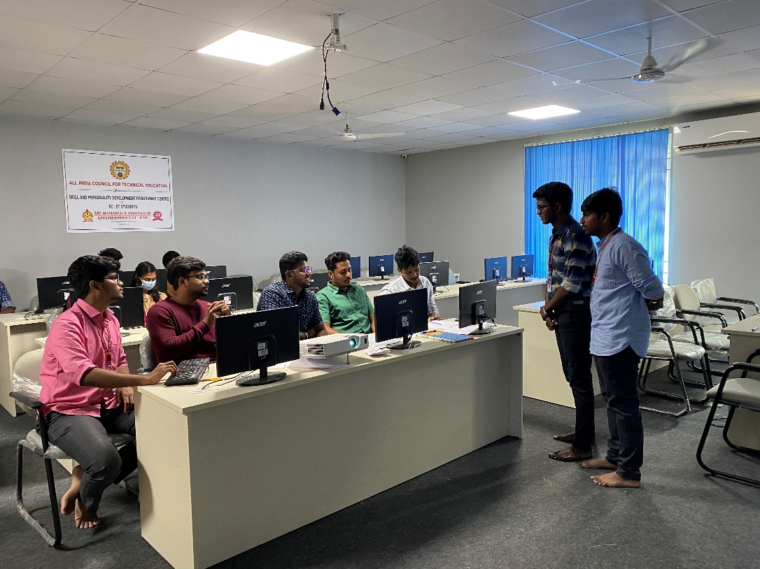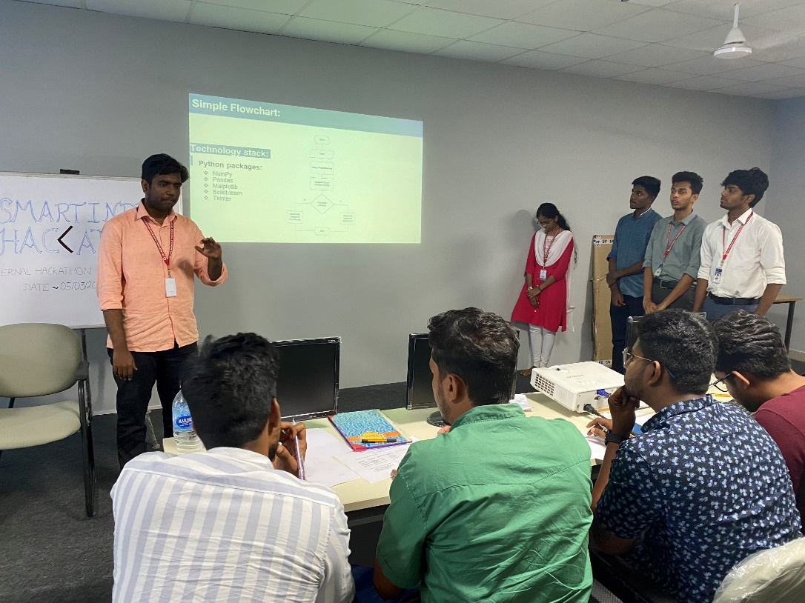Our department conducted the INTERNAL HACKATHON EVENT on 5th March 2022, Saturday.

**The event comprises of**

1. The Registrations began from 2nd March 2022 and ended on 4th March 2022.Total number of students registered in the Internal Hackathon event was 54 among which boys - 37 and girls -17.
2. The Pre-Event Discussion/Summit: 5th March, 2022 (02:00 pm to 04:00 pm ideation time was discussed among students at **AI&DS Lab)**

* **Topics Covered:**  
  1. Innovation and Out-of -Box thinking  
  2. Hackathons and Jugaadathons  
  3. Why Hackathon?  
  4. Converting hacks/jugaads into a sustainable business  
  5. Startup India and Make-in-India  
  6. Discussions and Ideation

1. 6 students should be registered as a team with their respective team names.
2. The views and ideas of each team was discussed and suggestions were given by our College Alumni’s.
3. The registered teams participated on 5th march 2022 were judged, out of which 5 teams were selected by our jury’s and are listed below:

|  |  |  |  |  |  |  |  |
| --- | --- | --- | --- | --- | --- | --- | --- |
| **S.No** | **Team Name** | **Problem Statement Id** | **Category (Software/**  **Hardware/Both)** | **Problem Statement Name** | **Email ID and Mobile No of Student** | **Mentor Name & Designation** | **Jury Score**  **(100)** |
| **1** | **TITANS** | **DB880** | **SOFTWARE** | **ENAID** | **1.GOKUL PRASATH**  [g**okulprasanth100702@.com**](mailto:gokulprasanth100702@.com)  **9943170426**  **2. RAGUL . .S**  [**Slrk4444@gmail.com**](mailto:Slrk4444@gmail.com)  **3.HARIGUPTHA.A**  [**harihariguptha@gmail.com**](mailto:harihariguptha@gmail.com)  **9080584360**  **4.MOHITA.V**  [m**ohivelu01@gmail.com**](mailto:mohivelu01@gmail.com)  **9791080985**  **5.GHAYATRI.H**  [**Ghayu1529@gmail.com**](mailto:Ghayu1529@gmail.com)  **8438665029**  **6.AISWARYA.A.V**  [**alvaiswary@gmail.com**](mailto:alvaiswary@gmail.com)  **7094309929** |  | **81** |
| **2** | **DATA WITH DESTINY** | **SM946** | **SOFTWARE** | **PREDICTION OF PNEUMONIA** | **1.GANAPATHY**  [**ganapathyaids@smvec.ac.in**](mailto:ganapathyaids@smvec.ac.in)  **9080056455**  **2.LALITH KANTH**  [**lalithkanthaids@smvec.ac.in**](mailto:lalithkanthaids@smvec.ac.in)  **9566729529**  **3.ARAVINDH**  [**aravindhaids@smvec.ac.in**](mailto:aravindhaids@smvec.ac.in)  **6382106607**  **4.BOOMIKA**  [**boomikaannamalai2520@gmail.com**](mailto:boomikaannamalai2520@gmail.com)  **9345553085**  **5. VALAR OLI**  [**olivalar287@gmail.com**](mailto:olivalar287@gmail.com)  **9514448585**  **6. VARSHINI**  [**varshiniaids@smvec.ac.in**](mailto:varshiniaids@smvec.ac.in)  **6385473354** |  | **77** |
| **3** | **LUCID THINKERS** | **NR1099** | **SOFTWARE** | **TO AUTOMATE AND COMPUTE THE DETECTION OF POSSIBLE VLULNERABILITY TO DEPRESSION BEFORE ITS ONSET** | **1.VASAN.C**  [**vasanaids@smvec.ac.in**](mailto:vasanaids@smvec.ac.in)  **6385339037**  **2.BALAJI.S**  [**balajiaids@smvec.ac.in**](mailto:balajiaids@smvec.ac.in)  **6382472292**  **3. ADITHYAN.A**  [a**dithyanaids@smvec.ac.in**](mailto:adithyanaids@smvec.ac.in)  **7708266927**  **4. HARISH.E**  [**harishaids@smvec.ac.in**](mailto:harishaids@smvec.ac.in)  **8300949331**  **5.GAYATHRI.S**  [**gayathriaids@smvec.ac.in**](mailto:gayathriaids@smvec.ac.in)  **8526329498**  **6. PARKKAVAN.I**  [**parkkavanaids@smvec.ac.in**](mailto:parkkavanaids@smvec.ac.in)  **7598606206** |  | **73** |
| **4** | **TECHNO SAPIENS** | **ST890** | **SOFTWARE** | **INSUFFICIENT MEDICAL SUPPORT AND REMOTE VILLAGE IN HILL AREAS** | **1.ROHIT.S.K**  [r**ohitsk2003@gmail.com**](mailto:rohitsk2003@gmail.com)  **9884511376**  **2.FERON AROCKIAM.S**  [f**eronarockiam1493@gmail.com**](mailto:feronarockiam1493@gmail.com)  **9944427493**  **3.HARII SARAVANAN.A**  [h**ariisaravanan99@gmail.com**](mailto:hariisaravanan99@gmail.com)  **9791240115**  **4. ANDREW JASON.R**  [**andrewjasonr@gmail.com**](mailto:andrewjasonr@gmail.com)  **8903670387**  **5.NARESH.S**  [n**areshsuresh589@gmail.com**](mailto:nareshsuresh589@gmail.com)  **9626390122**  **6.ABITHA.S**  [a**bithas2711@gmail.com**](mailto:abithas2711@gmail.com)  **6380507365** |  | **70** |
| **5** | **CODE X SYNDROME** | **PK847** | **SOFTWARE** | **VOICE BASED DELIVERY OF ACADEMIC RECORDS** | **1.KAVIN.B**  [k**avinbala7@yahoo.com**](mailto:kavinbala7@yahoo.com)  **9994853209**  **2.VIJAY.S**  [v**ijayvas1973@gmail.com**](mailto:vijayvas1973@gmail.com)  **9487619382**  **3.SHARAN ARAVIND.B**  [s**haranaravind87@gmail.com**](mailto:sharanaravind87@gmail.com)  **9994136361**  **4. SHARANJEY.G**  [s**haranjey023@gmail.com**](mailto:sharanjey023@gmail.com)  **9486659224**  **5. LOK NAARAAYAN SINGH.C**  [s**ithuijsingh29@gmail.com**](mailto:sithuijsingh29@gmail.com)  **9940518408**  **6.AKSHITHA.R**  [**akshittar@gmail.com**](mailto:akshittar@gmail.com)  **8248372695** |  | **69** |

**HACKATHON JURY’S DETAILS:**

1. NEVINKUMAR.A

SYSTEM ENGINEERING

TCS, CHENNAI

[nevinrocky6@gmail.com](mailto:nevinrocky6@gmail.com)

9629360207

1. JEEVANANTHAM

DEVELOPER

ZOHO,CHENNAI

[d.jeeva6@gmail.com](mailto:d.jeeva6@gmail.com)

7373638389

1. JAWAHAR

SYSTEM ENGINEERING

TCS,CHENNAI

[Jawahara1997@gmail.com](mailto:Jawahara1997@gmail.com)

8754747001

1. DHAMODHARAN

SAP CONSULTANT

KAAR,SAUDI ARABIA

[dhamo.exortian@gmail.com](mailto:dhamo.exortian@gmail.com)

9952478932

**HOD/ AI&DS**